MEASUREMENT DATA

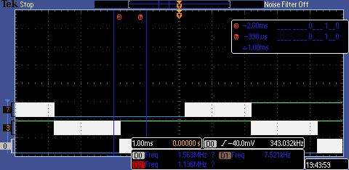
Figure 1. Profile of round-robin thread-switching

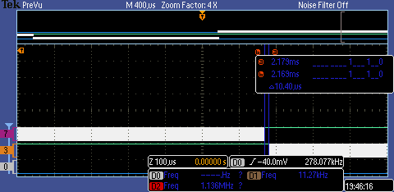
Figure 2. Profile measuring time for thread switch

Performance Measurements, with and without profiling instruments:

pid work (10 seconds):
with profiling: 962
without profiling: 1175
with button pushes: 1057

Performance Measurements for different timeslices (FIFO size only has a default value)

TIMESLICE (ms) DataLost Jitter PIDWork
2 0 200 1004
1 0 200 1287
10 0 200 1262

ANALYSIS & DISCUSSION
1) If the UART is interrupt driven, than unpredictable high-priority interrupts will increase the jitter.

3) DAS: priority 1; ADC: priority 3; Button: priority 2; SysTick: priority 7. The reason behind these priorities is to give the real-time tasks the highest priorities to minimize jitter.

5) The OS_Kill() statements at the end of Consumer and Display should always be executed, as once the ADC has sampled enough data via Producer they should exit their while() loops and t hen execute OS_Kill(). However, based on observation, this doesn't always happen.

7) Based on the length of the timeslice, it is unlikely that Consumer ever waits on OS_MailBoxSend, as it has to wait for 64 samples from the ADC and then compute the FFT from them in between calls. As long as a thread switch happens during that time, allowing Display to empty the mailbox, it won't have to wait.

